LAB 10 TASKS

Task 1:
You are creating a small tool for a teacher who wants to record attendance.
Create a Student class that stores:
- Name
- Roll number
Task:
Make an object of this class for two students and print their details.
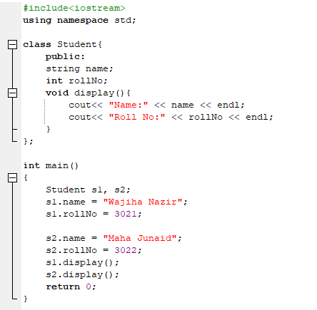
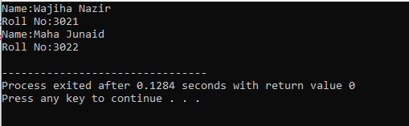

Task 2:
A bookstore app needs to allow updating the book price safely.
Create a Book class with:
- title
- price
Use getters/setters.
Task:
Update the book price and print the new price.
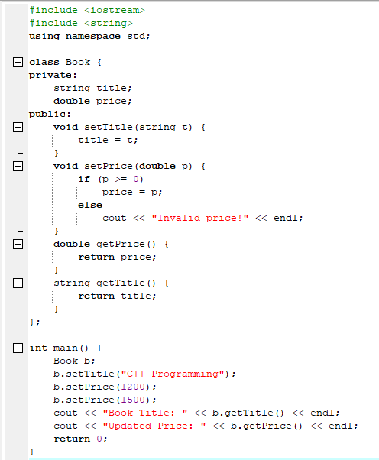
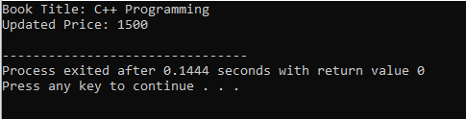

Task 3
Patient medical record must be protected.
Create a Patient class:
- private age
- private disease
- setters/getters
Task:
Set the data using setters and print using getters.
